FIELD REPORT
Introduction
- Place: Okwerodot HC III
- Location: Okwerodot, Kole district
- Date of visit: 26th August 2026

1. General observations
- The verification team met with the Head Teacher, who provided support and guidance throughout the asset verification exercise.
- UgIFT-supported classroom desks, laboratory equipment and other furniture were physically verified at the school and all furniture items were cross-checked against the school inventory book. However, the original delivery notes for the UgIFT assets were not available at the school at the time of verification.
- Some defects were observed in the UgIFT-supported infrastructure. These included doors and windows that could not be opened or closed properly, as well as a crack in the ceiling board of the office.
- The school reported that the water tank has never been put into effective use since it was installed because the pump does not work. Consequently, it is currently unable to provide water to the laboratory as intended.
2. Special notes
- The absence of engraving or permanent identification marks on the UgIFT-supported furniture made it difficult to distinguish program assets from other school property. All UgIFT assets should therefore be properly engraved or labelled to strengthen accountability and facilitate future verification.
- Delivery notes were not available at the school, and verification was therefore conducted using the school inventory book. The school should obtain copies of the relevant delivery documentation from the district and maintain them together with its asset records.
- Defects were identified in some components of the UgIFT-supported infrastructure, particularly doors, windows and the office ceiling. These defects require attention to ensure that the facilities remain safe, functional and fit for purpose.
- The water tank has reportedly remained unused since installation due to its poor condition. Its non-functionality is affecting the intended supply of water to the laboratory and may negatively affect laboratory operations.
- The responsible contractor should be engaged to inspect and rectify the identified construction defects, including the doors, windows and damaged ceiling board, and to repair the water tank and restore it to full functionality.
The table below illustrates some physical status of the verified assets with photographic evidence.
Table XXX: Physical verification photos
OKWERODOT SEED SS SIGN POST | 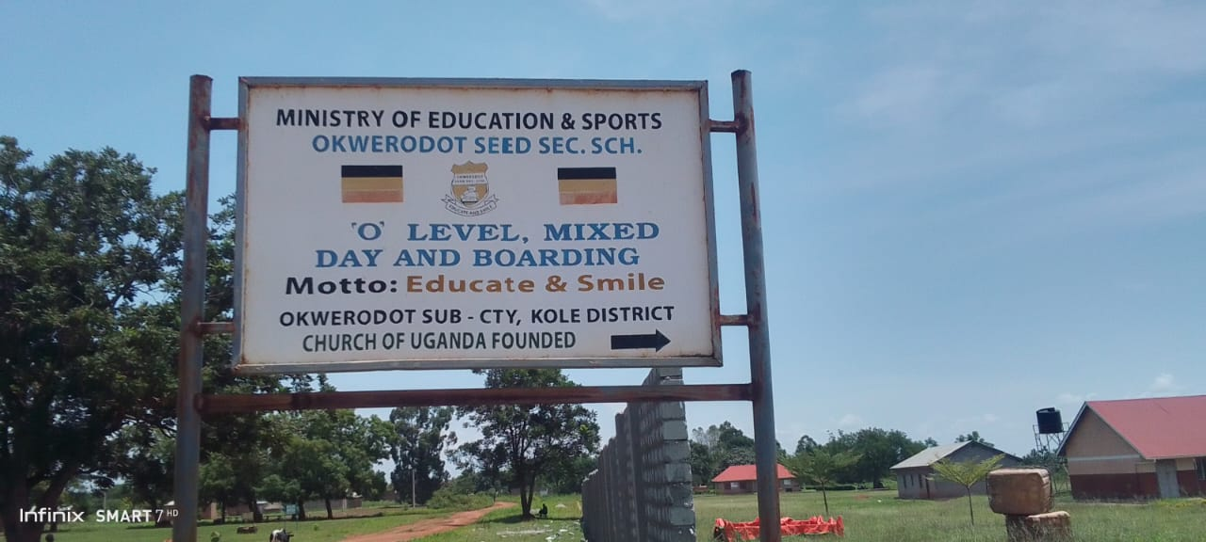
TYPICAL SET OF STAFF QUARTER’S BLOCK  (HOUSE BLOCK WITH TWO UNITS) | 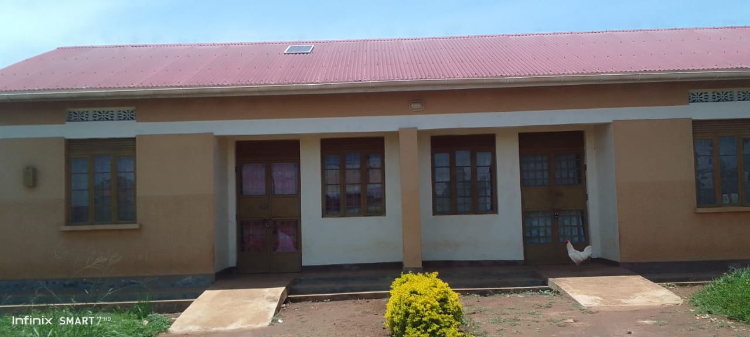
TYPICAL SET OF STAFF QUARTER’S BLOCK  (HOUSE BLOCK WITH TWO UNITS, KITCHEN) | 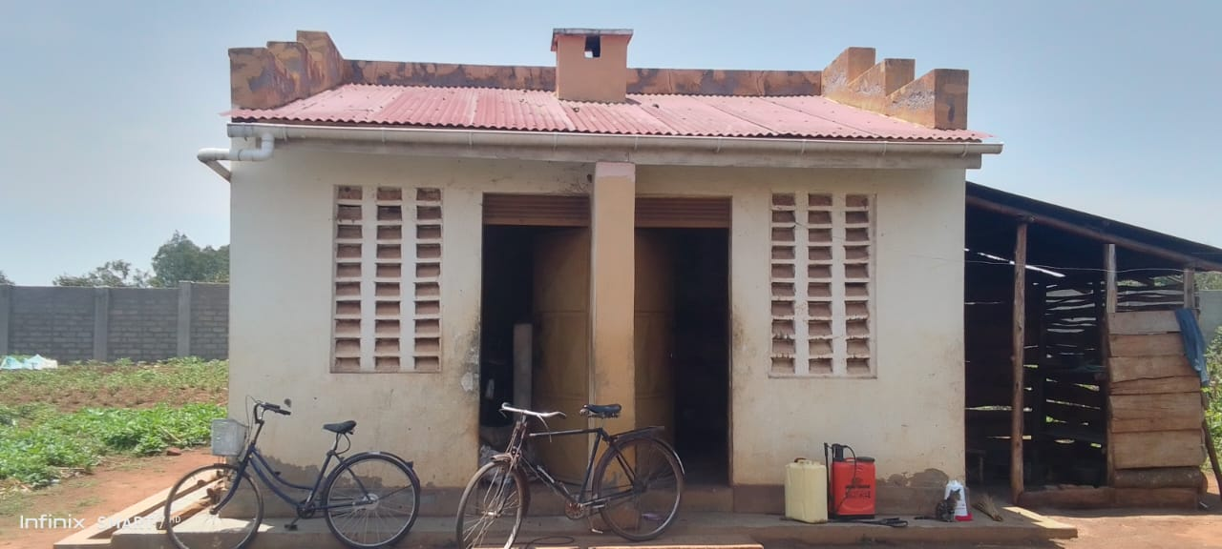
SCIENCE LABOLATORY BLOCK WITH TWO UNITS | 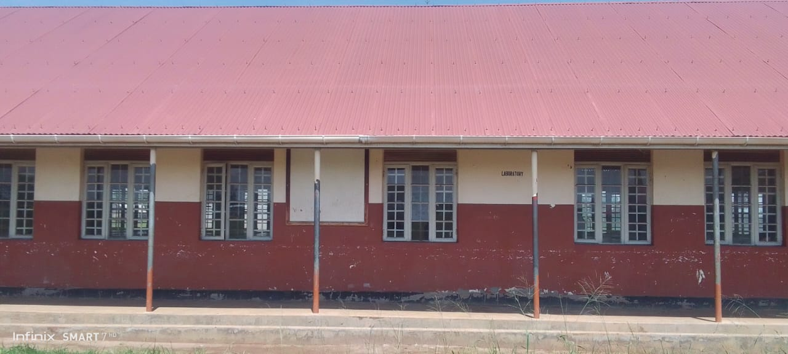
ADMINISTRATION BLOCK WITH TWO UNITS | 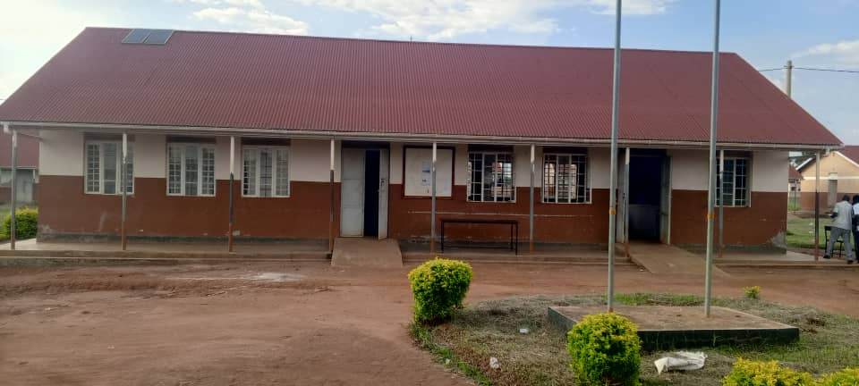
ICT /LIBRARY BLOCK | 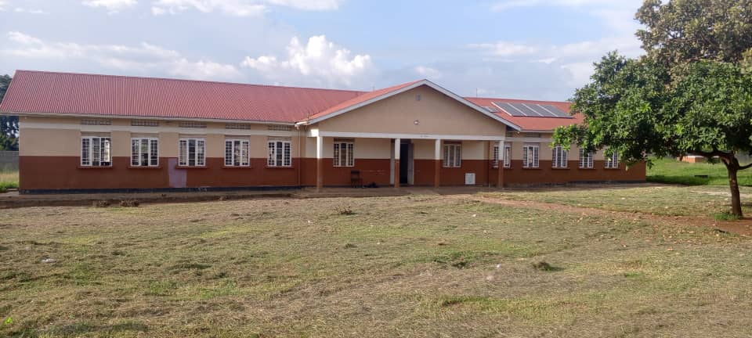
5,000LTRS HDPE CREST TANK WHICH FEEDS A 3,00OLTRS ELEVATED HDPE TANK WITH A PUMP | 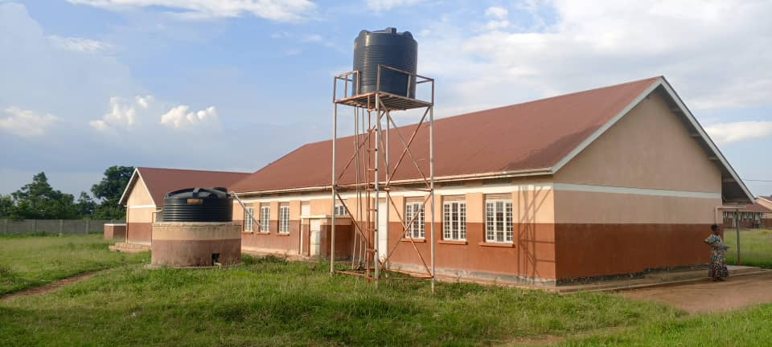
TYPICAL TWO UNITS CLASSROOM BLOCK | 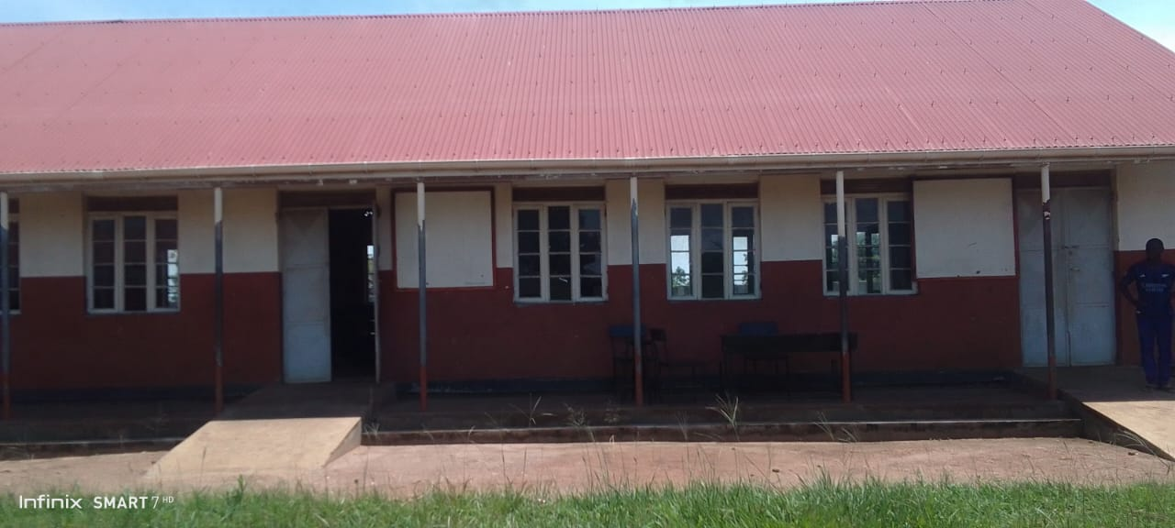
TYPICAL 5 STANCE VIP PIT LATRINE BLOCK | 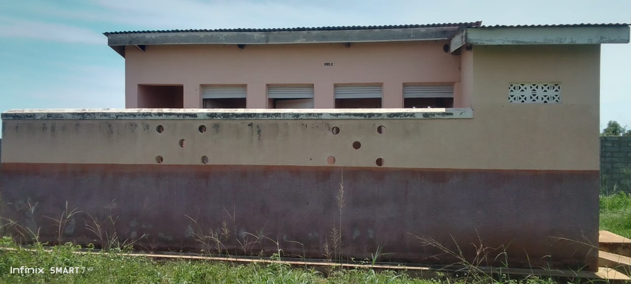
EPSON PROJECTOR | 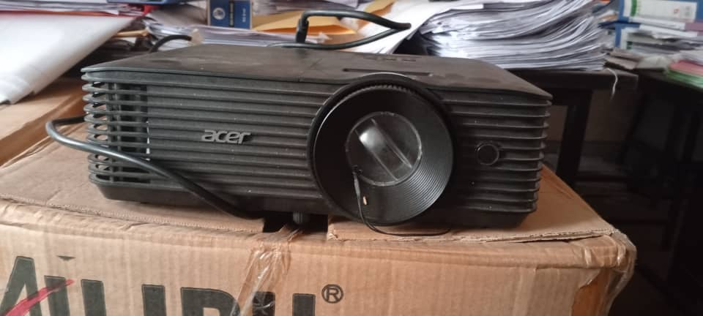
COMPUTER SET (MONITOR, UPS, POWER) | 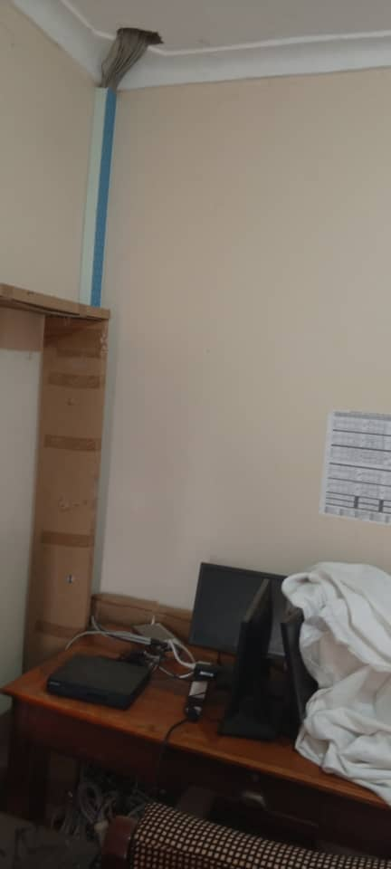
HP-3 IN ONE PRINTER | 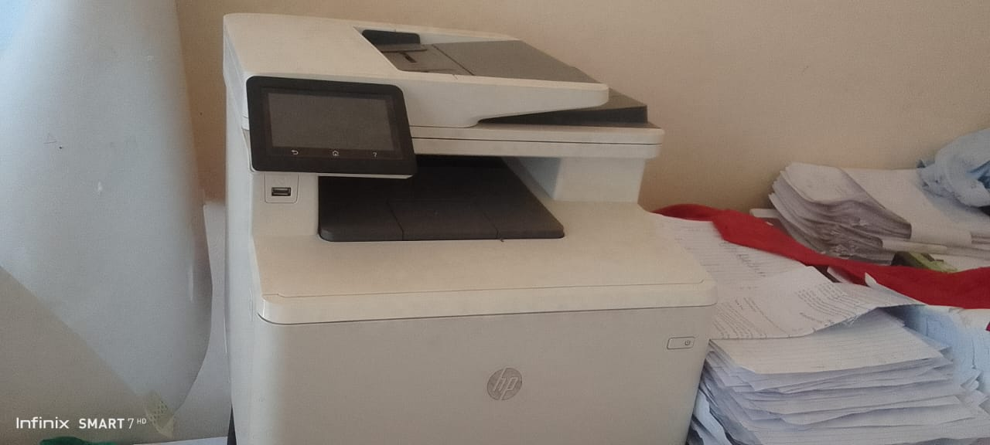
45KG-CYLINDER | 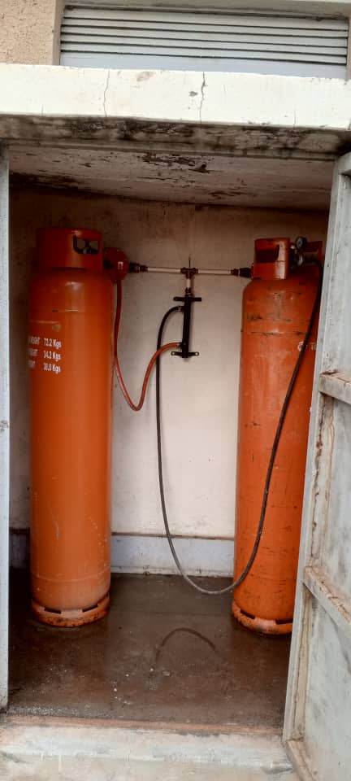
CCT CAMERA-ONE EYE | 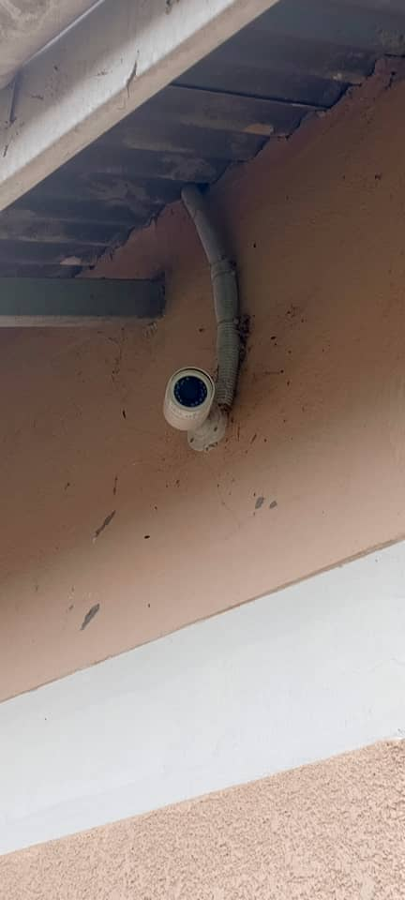
WALL LABORATORY TABLE WITH SHUTTERS, AND SINKS AND WATER CONNECTION | 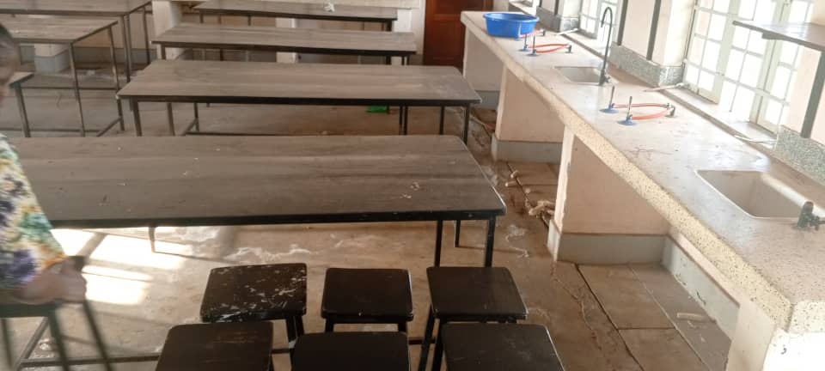
SAMPLE OF LAORATORY STOOLS | 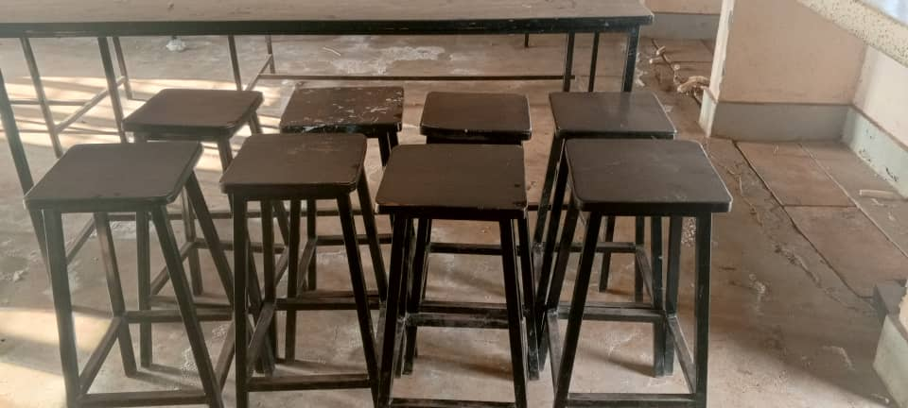
SAMPLE OF CHAIRS, ENGRAVED | 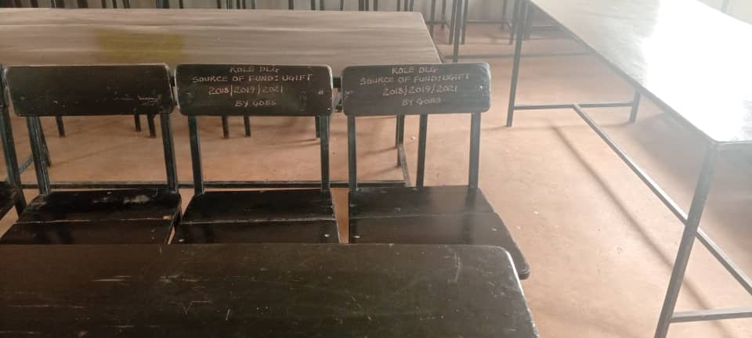
CHAIRS | 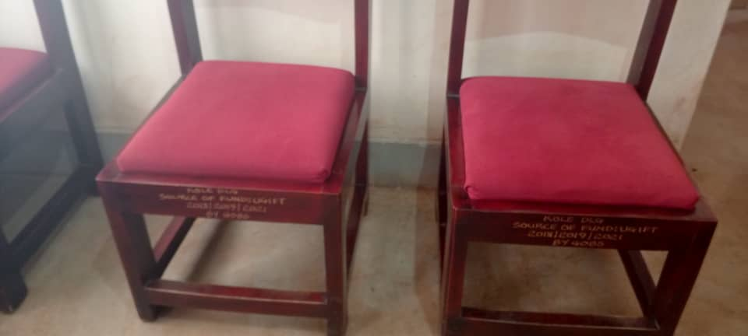
LIBRARY BOOK SHELVES, TABLES AND CHAIRS | 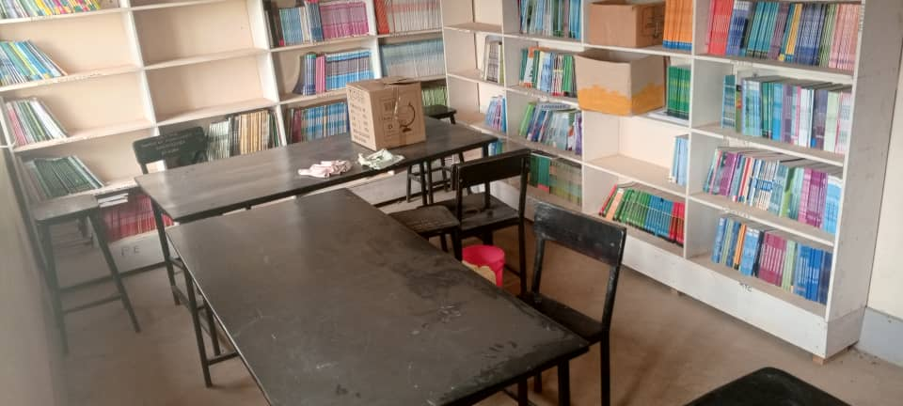
INTERIOR OFTHE COMPUTER LABORATORY | 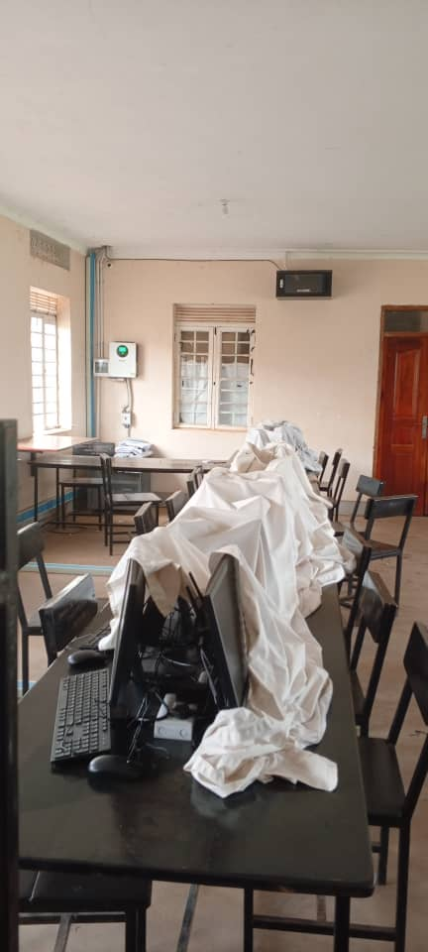
9KG-CO₂ FFIRE EXSTINGUISHERS | 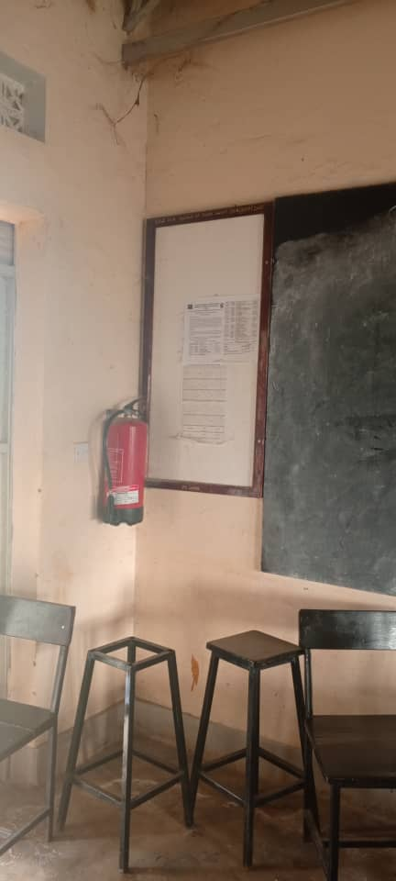
STAFF TOILETS | 